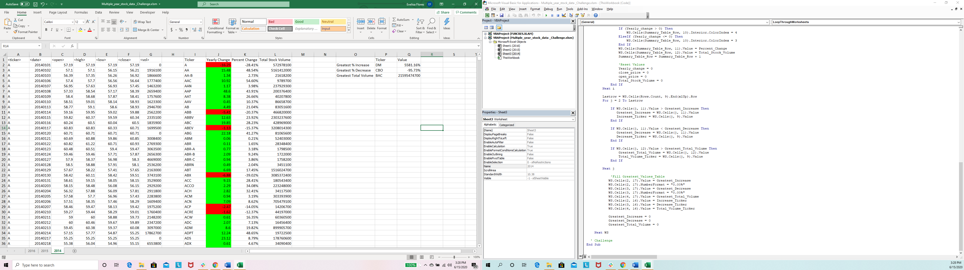

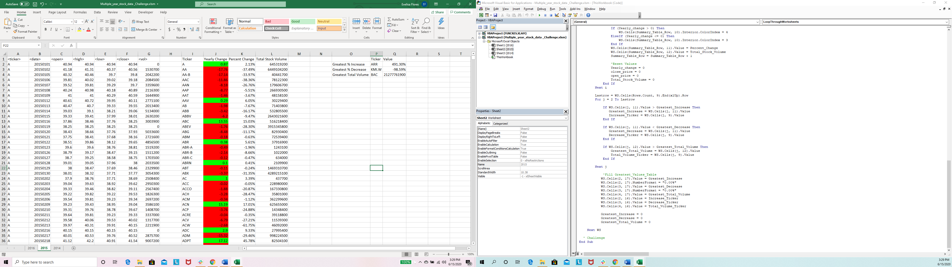

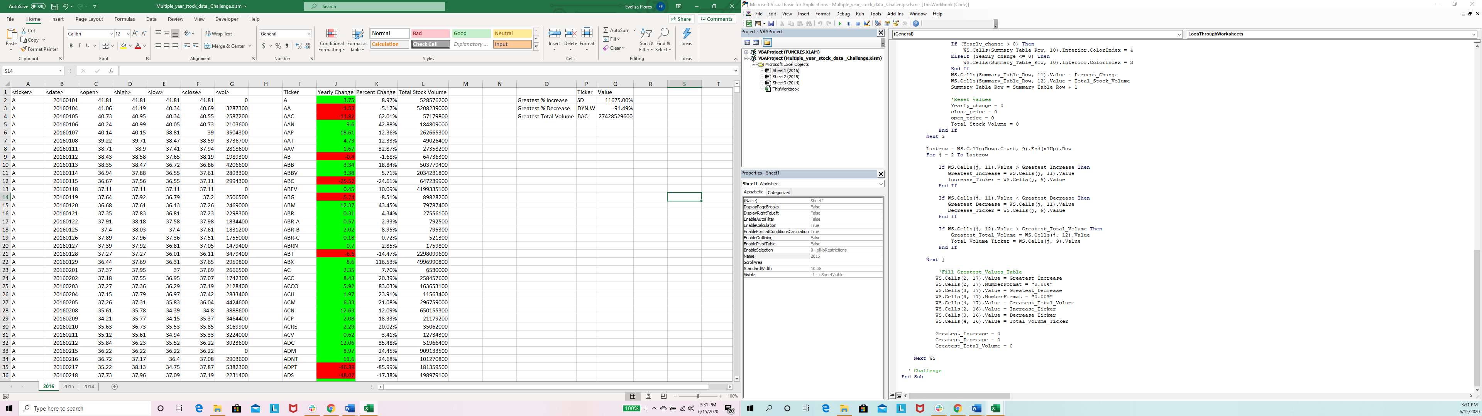

CHALLENGE SCRIPT

Sub LoopThroughWorksheets()

'Define Variables

Dim WS As Worksheet

'run through each worksheet

For Each WS In Worksheets

Dim ticker As String

ticker = ""

Dim open_price As Double

open_price = 0

Dim close_price As Double

close_price = 0

Dim Yearly_change As Double

Yearly_change = 0

Dim Percent_Change As Double

Percent_Change = 0

Dim Total_Stock_Volume As Double

Total_Stock_Volume = 0

Dim Summary_Table_Row As Long

Summary_Table_Row = 2

Dim Lastrow As Long

Lastrow = WS.Cells(Rows.Count, 1).End(xlUp).Row

Dim i As Long

i = 2

'Variables for Challenge

Dim Increase_Ticker As String

Increase_Ticker = ""

Dim Decrease_Ticker As String

Decrease_Ticker = ""

Dim Total_Volume_Ticker As String

Total_Volume_Ticker = ""

Dim Greatest_Increase As Double

Greatest_Increase = 0

Dim Greatest_Decrease As Double

Greatest_Decrease = 0

Dim Greatest_Total_Volume As Double

Greatest_Total_Volume = 0

Dim j As Long

j = 2

'set Column names,create summary table

WS.Cells(1, 9).Value = "Ticker"

WS.Cells(1, 10).Value = "Yearly Change"

WS.Cells(1, 11).Value = "Percent Change"

WS.Cells(1, 12).Value = "Total Stock Volume"

'set Challenge Summary Table,names

WS.Cells(2, 15).Value = "Greatest % Increase"

WS.Cells(3, 15).Value = "Greatest % Decrease"

WS.Cells(4, 15).Value = "Greatest Total Volume"

WS.Cells(1, 16).Value = "Ticker"

WS.Cells(1, 17).Value = "Value"

'Loop Through Worksheets

For i = 2 To Lastrow

'To fix open price of the month

If WS.Cells(i, 1).Value <> WS.Cells(i - 1, 1).Value Then

open_price = WS.Cells(i, 3).Value

End If

'To determine the total stock volume for the year

Total_Stock_Volume = Total_Stock_Volume + WS.Cells(i, 7).Value

'To see if it's the same Ticker

If WS.Cells(i + 1, 1).Value <> WS.Cells(i, 1).Value Then

'Find Values

ticker = WS.Cells(i, 1).Value

close_price = WS.Cells(i, 6).Value

Yearly_change = close_price - open_price

If open_price = 0 Then

Percent_Change = 0

ElseIf open_price <> 0 Then

Percent_Change = (Yearly_change / open_price)

End If

WS.Columns("K").NumberFormat = "0.00%"

'Fill the Results Table and color

WS.Cells(Summary_Table_Row, 9).Value = ticker

WS.Cells(Summary_Table_Row, 10).Value = Yearly_change

If (Yearly_change > 0) Then

WS.Cells(Summary_Table_Row, 10).Interior.ColorIndex = 4

ElseIf (Yearly_change <= 0) Then

WS.Cells(Summary_Table_Row, 10).Interior.ColorIndex = 3

End If

WS.Cells(Summary_Table_Row, 11).Value = Percent_Change

WS.Cells(Summary_Table_Row, 12).Value = Total_Stock_Volume

Summary_Table_Row = Summary_Table_Row + 1

'Reset Values

Yearly_change = 0

close_price = 0

open_price = 0

Total_Stock_Volume = 0

End If

Next i

Lastrow = WS.Cells(Rows.Count, 9).End(xlUp).Row

For j = 2 To Lastrow

If WS.Cells(j, 11).Value > Greatest_Increase Then

Greatest_Increase = WS.Cells(j, 11).Value

Increase_Ticker = WS.Cells(j, 9).Value

End If

If WS.Cells(j, 11).Value < Greatest_Decrease Then

Greatest_Decrease = WS.Cells(j, 11).Value

Decrease_Ticker = WS.Cells(j, 9).Value

End If

If WS.Cells(j, 12).Value > Greatest_Total_Volume Then

Greatest_Total_Volume = WS.Cells(j, 12).Value

Total_Volume_Ticker = WS.Cells(j, 9).Value

End If

Next j

'Fill Greatest_Values_Table

WS.Cells(2, 17).Value = Greatest_Increase

WS.Cells(2, 17).NumberFormat = "0.00%"

WS.Cells(3, 17).Value = Greatest_Decrease

WS.Cells(3, 17).NumberFormat = "0.00%"

WS.Cells(4, 17).Value = Greatest_Total_Volume

WS.Cells(2, 16).Value = Increase_Ticker

WS.Cells(3, 16).Value = Decrease_Ticker

WS.Cells(4, 16).Value = Total_Volume_Ticker

Greatest_Increase = 0

Greatest_Decrease = 0

Greatest_Total_Volume = 0

Next WS

' Challenge

End Sub